The Stonewall Riots: The Liberation of the LGBTQ+.

Mielle Rundall
Junior Division
Historical Research Paper
Student-Composed Words: 2,430

“Freedom from limits on thoughts or behavior” is the definition of liberation. People in The Lesbian, Gay, Bisexual, Trans, Queer, and more (LGBTQ+) community began to fight for liberation on the 1960’s .On the late night of June 28th, 1969 phones across Greenwich Village, New York began to ring with the news of the Stonewall Inn, the city's beloved gay club, being raided. People told that you needed to get down there, it seemed like the group outside would revolt. This night felt different, this was something more than the usual harassment combated with little fighting. This was something important. More and more people stopped and waited with the crowd slowly forming outside the club. Homosexuals and transgender were carted out, most handcuffed and scared out of their minds, but they still blew kisses. Nevertheless in the late 1960s most people in the LGBTQ+ community began to fight for their rights with a variety of demonstrations and social experiments. The Stonewall Riots in Greenwich Village were a turning point for the movement, bringing forward a mass of people fighting for their human rights. (see Appendix A). In the 1960’s it was disgusting to be in the LGBTQ+ community and you were battered and beat down for loving who you loved. James A. Baldwin said this: “Everybody's journey is individual. If you fall in love with a boy, you fall in love with a boy. The fact that many Americans consider it a disease says more about them than it does about homosexuality.” This quote really showcases how it was in the 1960’s for homosexuals and the horrible hate they faced.
In the 1960’s the world had a lot of prejudice for things they didn't understand or things that were different from the “norm”. It wasn't until 1975 that being gay was considered a lifestyle and not a sickness. The LGBTQ+ community was hugely argued over, whether it was right or wrong. What to do if someone was a lesbian or gay. During the time of the Stonewall riots there were many other people experiencing extreme prejudice: African Americans and women. There were also many corrupt police. Through the public eye it seemed as though the police were becoming increasingly aggressive. During the 1960’s there were many under the radar gay clubs, because at the time it was illegal to serve alcohol to a homosexual because being a homosexual was highly inappropriate. One of the most popular gay clubs was the Stonewall Inn because they had music and anyone would be let in. Although it was very risky to visit one of these clubs, many still did. If authorities found out you were gay, you could be fired from your job, jailed, or even killed. Not to mention the shame that you would feel, most were not ashamed or they had not started out ashamed but at the time it was disgusting to be gay. The hate that came from everyone if you were gay. Heartbreakingly it sometimes even came from your own family. There were many rules when it came to what a homosexual could and couldn't do. One of the rules during the time was that every citizen was expected to wear at least three “gender appropriate” clothing items. This could not include socks, or any undergarments. This greatly affected many people, for it forced some to be who they were not. Chaz Bono said “For me, it was never a question of whether or not I was transgender. It was a question of what I'd be able to handle transitioning and having to do it in the public eye. One of the issues that was hard for me to overcome was the fear of that.” This quote shows how this man really was affected by the laws and the prejudice.
At the time, many young LGBTQ+ people were living on the streets because when they came out to their families, their families would no longer associate with them. Many teens were branded with irons or had scalding water thrown at them. Many of these teens would find refuge at the Stonewall because it was easy to get in--you only needed to get past the club’s bouncer. It may have been easy to get into the Stonewall but that did not mean that there was still no repercussions for those who visited. Although many people in the LGBTQ+ community disagree, the official reason given by the authorities for closing the Stonewall was entanglement with the mafia. During this time there was a lot of mafia crime, including blackmail and possibly killing you. A police officer named Seymour Pine was tasked with stopping all the blackmail and mafia activity. He saw the Stonewall Inn as the center of the crime. Many gay people had started to steal from their employers because they needed to pay off the mafia who were threatening to tell the people's loved ones, the city, or even worse, the authorities if they were gay. The mafia targeted many gay clubs because it was easier to bend the peoples will by threatening to out them. People were raised to think that being gay was a disgrace. The idea of important people finding out what terrifying. Pine didn’t think that this would be enough of a reason to close the club, so instead he planned to close it for serving alcohol without a license.
On the night of June 28th, 1969 the lights flickered in the Stonewall Inn which would end up marking a catalyst in the fight for equal rights. The patrons all went on edge. This was a code that meant there was a raid happening and the crowd knew it meant danger. There had been a raid earlier that week. Pine had gone to get proof that the Stonewall was serving alcohol illegally. Officer Pine had brought back the Stonewalls alcohol stash and a few employees back to the station. Officer Pine had a plan to raid the Stonewall again to shut it down. Pine hired six officers to help him, all from neighboring towns so that none would tip the club off. Pine sent in four undercover officers to observe and differentiate between patrons and employees. They would then come meet up with Pine and the whole group would go together to the Stonewall. Pine would announce that they were raiding and demand entrance. Pine had also hired a man who could check the alcohol and a club inspector who could tell them if the club was fit to be open. Once Pine had arrested all crossdressers and employes he would call for backup. Pine had also planned to remove the Stonewall’s key items such as the jukebox and bars. This would halt the use of the club even if they failed to shut the club down.
When they executed the plan there were a few bumps. Two of Pine’s officers had failed to meet him, and his inspector had failed to properly assess the club. His first order once they got into the Stonewall was to arrest all employees and crossdressers. Gender reassignment therapy had just started and that made it increasingly hard to tell the difference. Patrons who had IDs were released one by one, then anyone without a proper ID was detained. The people being let out formed a crowd outside the Stonewall, as many still had friends inside. People walking past the Stonewall began to join the crowd.
Once everyone legal was out of the Stonewall, police began parading employes and crossdressers out of the building in handcuffs. A hush fell over the growing crowd when the police vehicle drove up. No one understood what was happening. “Why don’t you guys do something?” someone had called out while being forced into a police vehicle, this is when the crowd outside the Stonewall started to fight back. Someone shouted to tip the car but they were driving away too quickly. The crowd grew intense starting with harsh words like “Pig” a term that is still seen as offensive, then they began throwing coins and shouting things like “Copper”. As the crowd grew the items being thrown grew. The crowd started to throw glass bottles (see appendix B). The crowd started to edge closer to police cars and began hitting them. The rage of the crowd was insane, they aimed to hurt the cops. At this point the cars were full and Pine needed their few backup police officers to drop their prisoners at the police station and then come back.
When Pine was left at the Stonewall with his original team he wasn’t sure what to do. He needed to keep the scene secure, but at that point the crowd was too big to control alone. He decided to retreat. So, he took his team into the Stonewall and barricaded the door while they waited for backup. As Pine was pushing his team into the building he asked a reporter if he wanted to join them inside. The reporter has mentioned having a hard deciding, because he didn't want to seem like a traitor to the crowd but he knew this would be an amazing opportunity.
Inside the club there were more detainees because the police vehicles were full. Pine entering the club gave the patrons on the outside a reason to fight more aggressively; Take back the Stonewall. A transgender queen named Martha P. Johnson threw a brick at the windows; one brick turned into an onslaught of bricks (see Appendix C). They called Pine’s team horrible names. All the bottled anger of the crowd had turned the protest into a harmful and potentially deadly event. Using a parking meter as a battering ram, the patrons broke down the door and began to throw bottles into the open door. They did not go in for fear of police guns. Pine grabbed Dave Van Ronk, a folk singer, as a hostage while his team babarcaded the door (see Appendix D). The team handcuffed the folk singer and beat him to near unconsciousness. After that, the officers continued to barricade while the others looked for weapons. They found a cut off baseball bat and a heavy tool. They continued to fight, but onlookers started to throw Molotov Cocktails made of soda bottles and anything flammable.
Pine was terrified for himself and his team and then he finally heard the whine of sirens. This was good news for Pine and his team but bad news for the crowd. Some ran for it but most stayed (see Appendix E). They were in it for the long haul and they would not be giving up any time soon. The police loaded up the leftover detainees and the alcohol. Disappointed people went home and woke up to the news of more gatherings all week. The fight was not over. Few stayed but the few who did told the others to come back the next night. They were not done fighting. They were told to spread the news and make sure as many people came as they could get.
The next night the Tactical Patrol Force (TPF) came to the riot. The TPF only came when there was something major that couldn't be handled by the regular authorities. The TPF formed a line by linking arms, they would walk around in this formation. If anyone got too close they would hit them with billy clubs. The TPF had one problem though: the “Christopher Street Queens” knew the streets better than anyone. They could run up to the TPF and flee into a back alley ways. They were able to trick the TPF by doing this, they could avoid being hurt by billy clubs. The Queens then began to form broadway kick lines and poke fun at the TPF. They did everything they could to take back Christopher Street.
The Stonewall Riots lasted six nights. The nights were filled with many harsh words and police. The streets were filled with amazing individuals who all fought like their lives depended on it. For some their lives it did, many peoples lives revolved around the gay bars. The community fought until they got the world to realize that they would not back down. The people who had previously been fighting more respectfully began to come together with the other enraged homosexuals and fight as hard as they could. Before the riots people needed to fight quietly with small protests and experiments.
Days after the riots the Gay Liberation Front wrote a pamphlet called “Come Out” which told the story of the Stonewall from the perspective of the homosexuals, and encouraged more people to come out of the closet. In the past coming out had been shameful and wrong, but this made coming out powerful and part of the movement (see Appendix F).
The change that was brought forward from the riots was immense. Months after the riots there was a parade in remembrance. This is now known as the first gay pride parade (see Appendix G). There are how many meaningful riots, homosexuals and many others of the LGBTQ+ community can be truly themselves. At the time most could not be their true selves. Two years after the riots a gay rights community/group had been formed in most major cities and people were actually coming around to the idea of being gay. Throughout the years these organizations have organized many rallies, protests, and movements to help in the lasting fight for gay rights.
Our world have made sincere compromises when it come to LGBTQ+ community. Before the riots being gay was illegal, now gay marriage is legal in all 50 U.S. states. During the riots the people weren't even looking for gay marriage, all they wanted was equality. Before the riots no one could have chosen anything to do with LGBTQ+ rights for school and the certainly could not have talked about it so openly. It would have been a risk to even choosing these riots as a topic.
The Stonewall Inn doorman stated to the police that “People are beginning to realize that no matter how ‘nelly’ or ‘fem’ a homosexual is, you can only push them so far. “. The world has significantly changed since the 1960’s, but a big push was gay rights. The world has since been able to overcome some of its prejudice and work to find an equal way of living. The world is still at work though, there is still extreme prejudice spread every day and many hate crimes. There will always be something somewhere that is not fair, because the world has its imperfections. It is this next generation’s job to fix those imperfections, and I hope someday we all do something that contributes. In the late 1960’s most people in the LGBTQ+ community began to fight for their rights with a variety of demonstrations and social experiments. The Stonewall Riots in Greenwich village were a turning point for the movement, bringing forward a mass of people fighting for their human rights.

Appendix A: The Stonewall Inn sign.
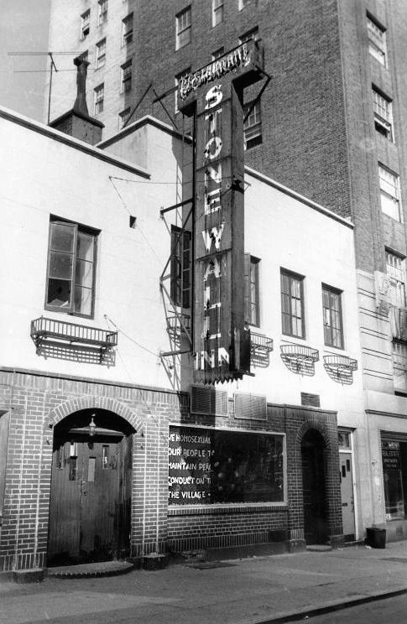
Appendix B: This is an image of the police fighting a man, he is resisting arrest.
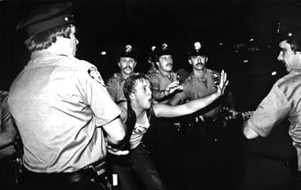

Appendix C: Martha P. Johnson, she threw the first brick at The Stonewall Inn. She has not been credited with this for a long time and by very few so this information is important.
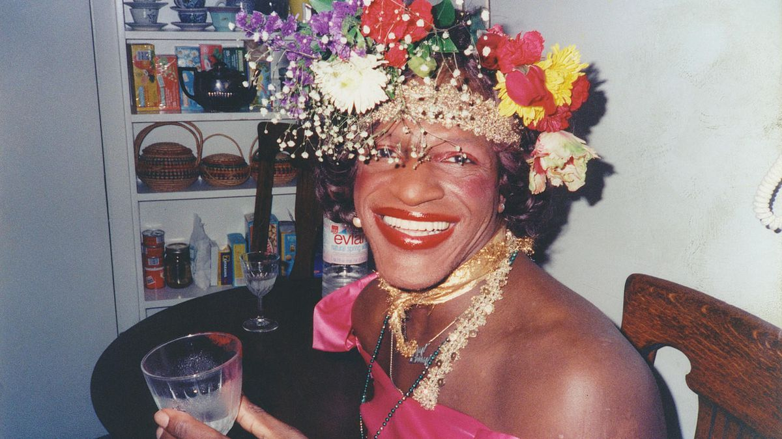

Appendix D: This is Dave Van Ronk, the man that Pine held hostage. He was a famous folk singer during the time, said to be a friend to everyone in the Village.
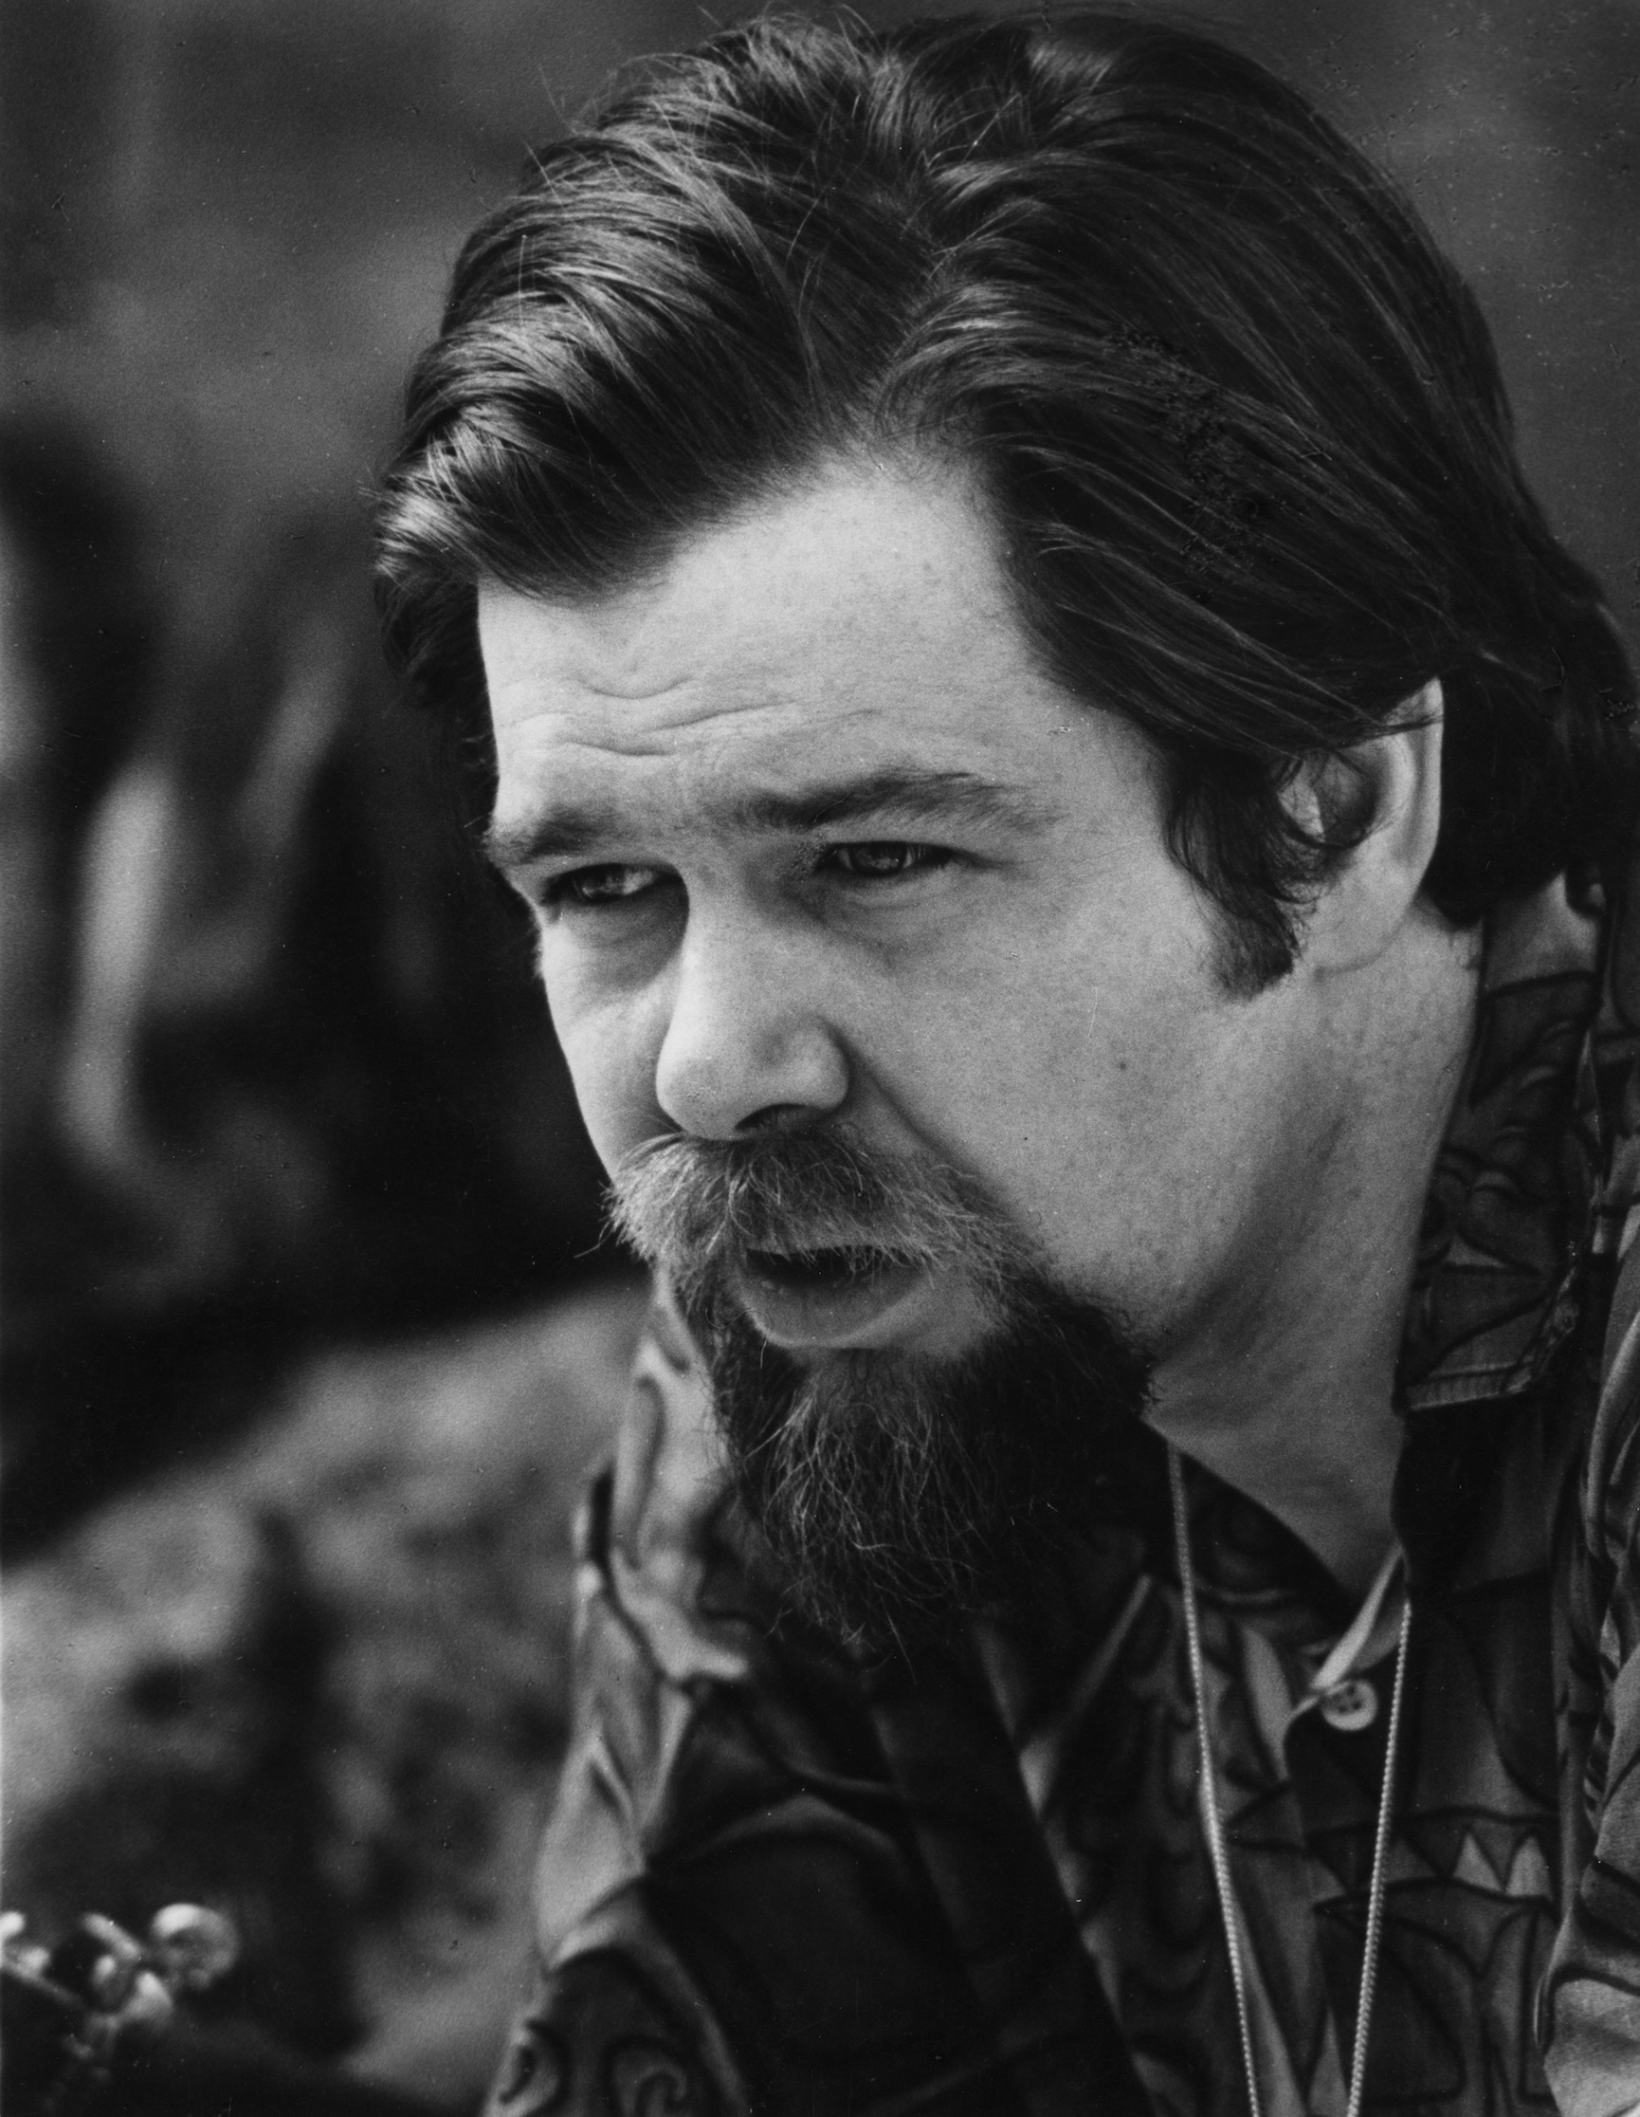
Appendix E: Police showed up.
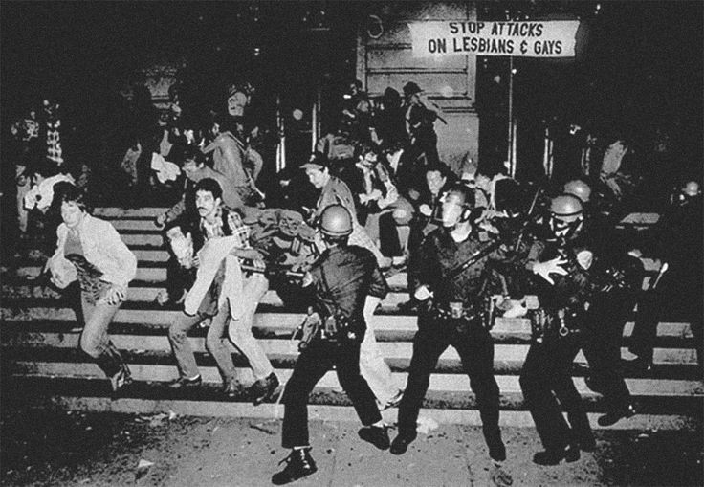

Appendix F: The famous “Come Out” pamphlet.
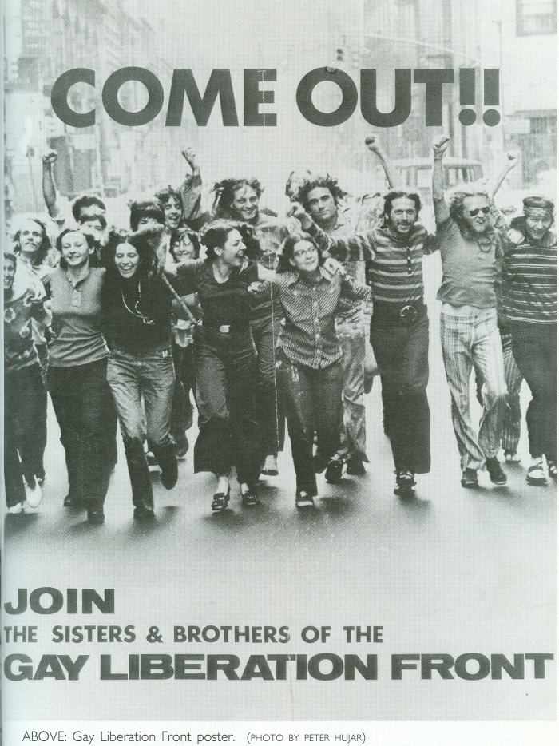
Appendix G: The first gay pride parade.
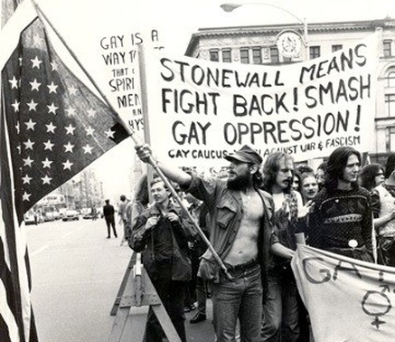

Annotated Bibliography

Primary Sources

Wolf, Sherry. “Stonewall: The Birth of Gay Power.” Stonewall: The Birth of Gay Power | International
Socialist Review, isreview.org/issue/63/stonewall-birth-gay-power.

This is an image that showcases how hard people were fighting and what the LGBTQ+ community was dealing with, I also took paraphrases from this website. This image helped my paper have more feeling and for people to see more of what was really happening during the time and I found good information about what happened after the riots.

Stonewall Breaking Out in the Fight for Gay Rights. Follettbound, 2017.

This book gave insider view on The Stonewall Riots and many facts that I didn’t previously know. This was my most helpful source, it helped my paper tremendously with information coming directly from people who participated in the riot and information that made my paper that much more powerful.

Dave Van Ronk at the 1968 Philadelphia Folk Festival.” Bandwidth.

This image gave a visual representation of my project and it helped me by putting more realness behind the essay.

The Stonewall Riot and Its Aftermath." Stonewall 25: Cases 1-2. N.p., n.d. Web. 13 Nov. 2017.

These accounts of the Stonewall gave an interesting inside view of the project. They helped my project by backing up facts, etc.

Stonewall Sign." Stonewall Sign. N.p., n.d. Web.

This is what the Stonewall Sign looked like at the time. This helped my project with background.

The Stonewall Riots." The Evolution of NYC — History 128. N.p., n.d. Web. 05 Dec. 2017.

This is an image of one of the first gay pride parades, this brought some visual for my change and compromise section.

Manford, Morty. “Eric Marcus, Making History .” Eric Marcus on SW25.

This account of the Stonewall brought in a personal element which I didn’t find in many different sources, this helped my project by bringing an even more personal touch to it.

Lisker, Jerry. "Homo Nest Raided, Queens Are Stinging Mad." Carnegie Mellon School of
Computer Science. N.p., n.d. Web. 09 Feb. 2018.
This was an article that was written after the Stonewall riots and it brought in some information for the change section of my essay.

Cns. "Ack Google Pledges $1 Million To Preserve LGBTQ Stonewall Inn Story." N.p., n.d. Web
This is an image of young people fighting against the police and trying to win their rights, this brought some background and realness to my essay.

"Come out." Come out. N.p., n.d. Web.

This is an image of a pamphlet that was printed after the Stonewall riots, it encouraged more and more people to come out and live their lives. This brings in some closure to my project, to see that things really were starting to look up for the LGBTQ+.

Secondary Sources

Singleton, Dave. “Stonewall Riots - What the Riots Mean to Me.” AARP, 1 June 2009.

This was an account of a man who was born in the late 60’s, this article brought some insight to my essay.

“Stonewall Riots .” History.com.

This website brought me credible information on what happened before and after the riots. This helped my project with fact checking and excess knowledge.

Franke-Ruta, Garance. "An Amazing 1969 Account of the Stonewall Uprising."The Atlantic. Atlantic
Media Company, 24 Jan. 2013. Web. 13 Nov. 2017.

This account of the Stonewall gave some interesting facts and things I didn’t know before, it helped my project by giving it more structure.

Green, Lucy Santos. "Stonewall and Its Impact on the Gay Liberation Movement." Stonewall and Its
Impact on the Gay Liberation Movement. Digital Public Library of America, 28 Sept. 2017.
Web. 09 Feb. 2018.

This article gave me interesting facts and ideas, this helped my project.

Grabianowski, Ed. “How the Stonewall Riots Worked.” HowStuffWorks, HowStuffWorks, 4 May 2017,
history.howstuffworks.com/historical-events/stonewall-riots5.htm.

This gave information on what happened after the Stonewall and it gave some real changes to the project.

“Stonewall Riots: The Beginning of the LGBT Movement.” The Leadership Conference on Civil and
Human Rights, 22 May 2017.

This gave some facts about what people think now and how people reacted, this helped my project with giving additional information.

Keith. "The Stonewall Riots: Gay People Stormed out of the Closet in 1969." Keith York City. N.p.,
21 Oct. 2012. Web. 09 Feb. 2018.

This source brought facts and personal insight, this helped my project.

"The Stonewall Riots – 1969." Socialist Alternative. N.p., n.d. Web. 09 Feb. 2018.

This source brought new information and insights to the topic, this helped my project have more backbone.

Lisker, Jerry. "Homo Nest Raided, Queens Are Stinging Mad." Carnegie Mellon School of
Computer Science. N.p., n.d. Web. 09 Feb. 2018.

This was an article written during the time, it was an account of the Stonewall and some pretty harsh opinions, this article shows how bad the prejudice actually was.

Worthen, Merideth. “Stonewall: The People, the Place, and the Lasting Significance of ‘Where Pride Began.’” Biography.com, 21 June 2017,

This source brought background information and knowledge about The Stonewall riots, this helped my project by adding background.

Stonewall Breaking Out in the Fight for Gay Rights. Follettbound, 2017.
Wolf, Sherry. "Stonewall: The Birth of Gay Power." Stonewall: The Birth of Gay Power | International Socialist Review. N.p., n.d. Web. 13 Nov. 2017.
Stonewall Breaking Out in the Fight for Gay Rights. Follettbound, 2017.
Ibid.
“Famous Quotes at BrainyQuote.” BrainyQuote, Xplore, www.brainyquote.com/.
Stonewall Breaking Out in the Fight for Gay Rights. Follettbound, 2017.
Stonewall Breaking Out in the Fight for Gay Rights. Follettbound, 2017.
Ibid.
Stonewall Breaking Out in the Fight for Gay Rights. Follettbound, 2017.
Stonewall Breaking Out in the Fight for Gay Rights. Follettbound, 2017.
Ibid.
Wolf, Sherry. “Stonewall: The Birth of Gay Power.” Stonewall: The Birth of Gay Power | International Socialist Review.
Singleton, Dave. “Gay Rights Movement: Stonewall Riots - What the Riots Mean to Me.”AARP, 1 June 2009
“Stonewall Riots: The Beginning of the LGBT Movement.” The Leadership Conference on Civil and Human Rights, 22 May 2017.
Stonewall Breaking Out in the Fight for Gay Rights. Follettbound, 2017.
Stonewall Breaking Out in the Fight for Gay Rights. Follettbound, 2017.

